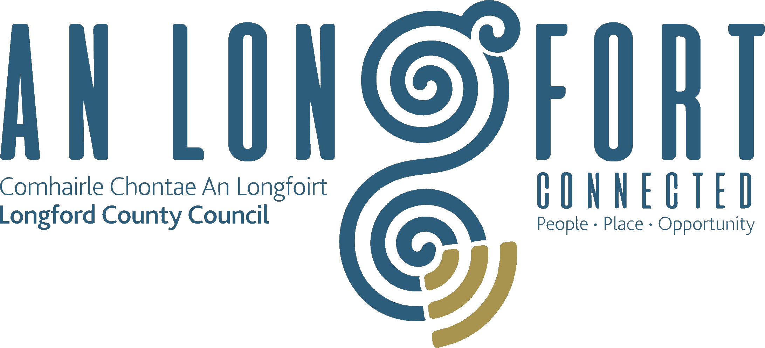

Minutes of Joint Policing Committee Meeting held in the Council Chamber,
Aras an Chontae, Longford on
Monday, 2nd March 2020 at 3.00 p.m.

PRESIDING: Councillor Seamus Butler.

PRESENT: Councillors - Uruemu Adejinmi, John Browne,
Micheal Carrigy, Gerry Hagan, Martin Monaghan,
Garry Murtagh, Turlough McGovern, Peggy Nolan,
P.J. Reilly, Paul Ross, Pat O’Toole and Gerry Warnock.
Sectoral Representatives - James Belton, Emma Kiernan,
Angela Keaveny, Ndidi Idehen, Niamh Donlon
and Pat Murphy.

Mr. Paddy Mahon, Chief Executive.
Mr. Ciaran Murphy, Senior Executive Officer.
Ms. Barbara Heslin, Director of Services.
Chief Superintendent Tony Healy.
Superintendent Jim Delaney.
Inspector Dave Jordan.
Inspector Adrian Flynn.

APOLOGIES:- Superintendent Seamus Boyle.

MEETINGS
ADMINISTRATOR: Anne Lee.

ADOPTION OF MINUTES.

On the proposal of Councillor P. Nolan seconded by Councillor G. Hagan, it was unanimously agreed to adopt the minutes of Joint Policing Committee meeting held on the 2nd December 2019, as circulated.

MATTERS ARISING.

None.

DECLARATION OF INTERESTS.

None

GARDA REPORT

Superintendent Delaney briefed the members on the following and replied to queries raised -

- Proactive policing.
- High visibility policing.
- Roads policing.
- Public order offences.
- Drugs offences.
- Thefts.
- Crime prevention.
- Feud management
- Community Initiatives.
- Crime statistics.
- Staff numbers.

Inspector Dave Jordan briefed the members on the following and replied to queries raised –

- Community Policing
- Bus parking in Granard.
- High visibility policing.
- Crime details
- Roads policing.
- Feuds in Granard and Edgeworthstown.
- Staff numbers.

LOCAL AUTHORITY REPORT.

C. Murphy provided an update on the following and replied to queries raised –

- Funding programmes.
- Community engagement.
- Resettlement programme.
- Sports Partnership programme.
- Housing programme.
- Library programme.
- Regeneration programme.
- Annual Plan – an annual progress report on the overall implementation of the Strategic Plan 2016 -2022 will be prepared in advance of the next JPC Meeting on the 8th June 2020.

LONGFORD JPC 2019 ANNUAL REPORT.

On the proposal of Councillor G. Hagan seconded by Councillor P. Nolan, it was unanimously agreed to adopt 2019 Longford Joint Policing Annual Report, as circulated.

UPDATE ON LONGFORD JOINT ACTION PLAN.

Mr. P. Mahon, Chief Executive, briefed the members on the positive improvements in the Ardnacassa area. Work on building community capacity, through local community groups, is ongoing.

DATE OF NEXT MEETING

8th June 2020.

AOB

A. Kearney raised the issue of Garda resources and supporting correspondence issued from the Joint Policing Committee to the Minister for Justice.

Chief Superintendent Tony Healy and Councillor Seamus Butler to discuss this issue further.

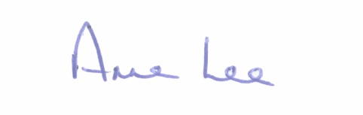
This concluded the business of the meeting.

Signed:
Anne Lee,
Meetings Administrator.

Confirmed and adopted at Joint Policing Committee Meeting held on the
6th July 2020.

Signed: __________________
Chairperson.

